

The Carson Valley Art Gallery Association presents

“SMALL TREASURES”

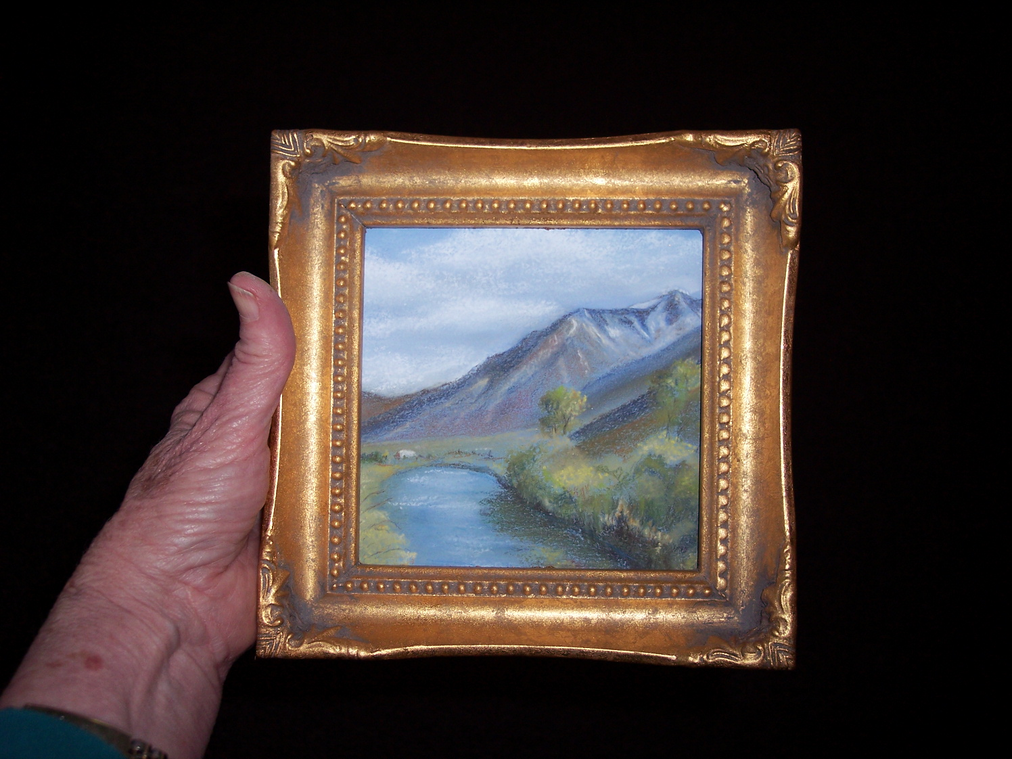

“Carson River” by Sabina Bye ~ 5” x 5” Framed Pastel

One of the five prizes that will be awarded in the Free Art Raffle
Pick up your free raffle ticket at each of the Carson Valley Art Galleries listed below.

A Juried Exhibit of Small Artworks

Now through July 31, 2008

Reception for the Artists at All Galleries

Thursday, July 3, 2008 from 5 PM to 9 PM

A shuttle will be available to take visitors to all five galleries.

Selected works from the total exhibit will be shown at the following galleries

ARTISANS INTERNATIONAL

GALLERY
1653 Lucerne St # B – Minden
(775) 783-8881

ARTISTIC VIEWPOINTS

GALLERY & STUDIO
1572 Hwy 395 N – Minden
(775) 783-0633

EAST FORK GALLERY

1503 Hwy 395 N – Gardnerville
(775) 782-7629

FELIX POTTERY & ARTISAN’S SHOPPE

1459 Hwy 395 N – Gardnerville

(775) 782-5434

LONE TREE GALLERY & FRAME
1598 Esmeralda Ave. – Minden
(775) 782-2522

❑

YOU MAY WIN FINE ART ~ Drawing on August 1, 2008
Free raffle tickets at Artists’ Reception & each gallery throughout exhibit. Winner need not be present to win.

